**APP & WEBSERVER TASK**

1.Install nginx and run nginx on port number 81.

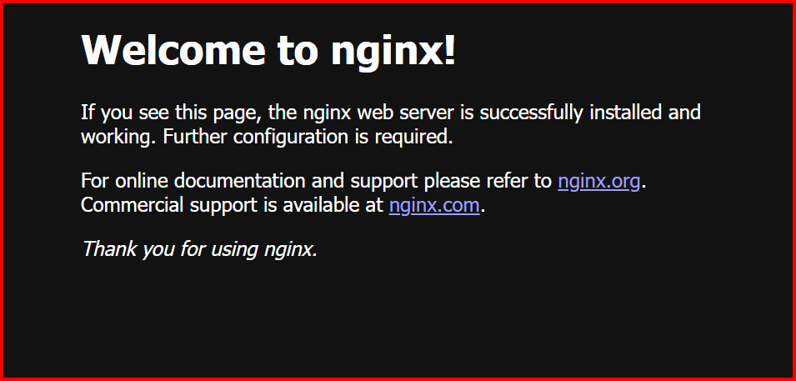

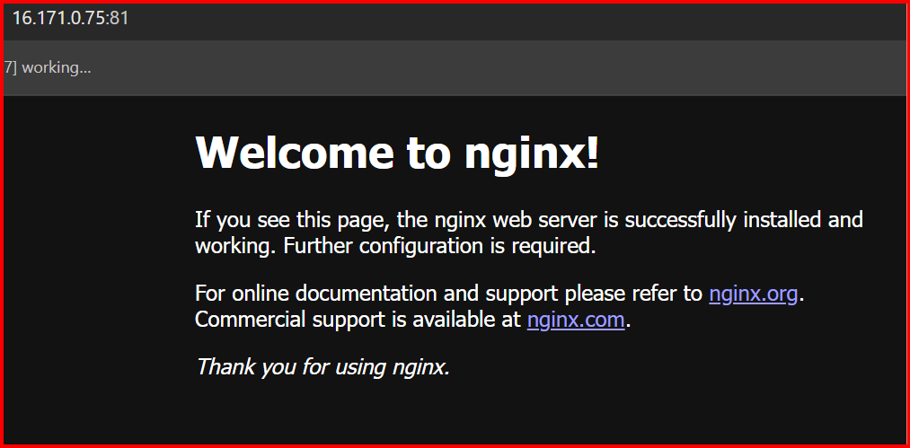

2. Deploy a sample index.html file on nginx

We should deploy 🡪 /var/www/html



3.Install Apache and run Apache on port number 82.

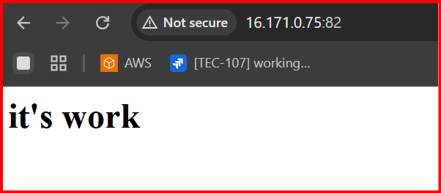

4. Deploy a sample index.html file on Apache.

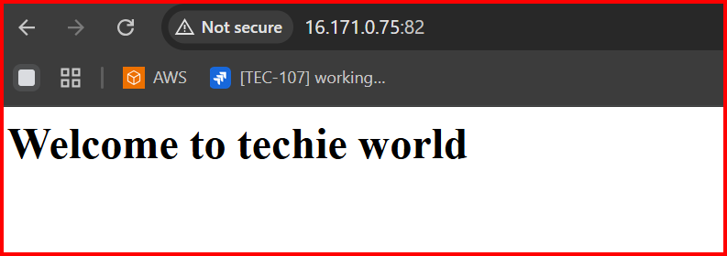

5. Install Apache tomcat on port number 8082.

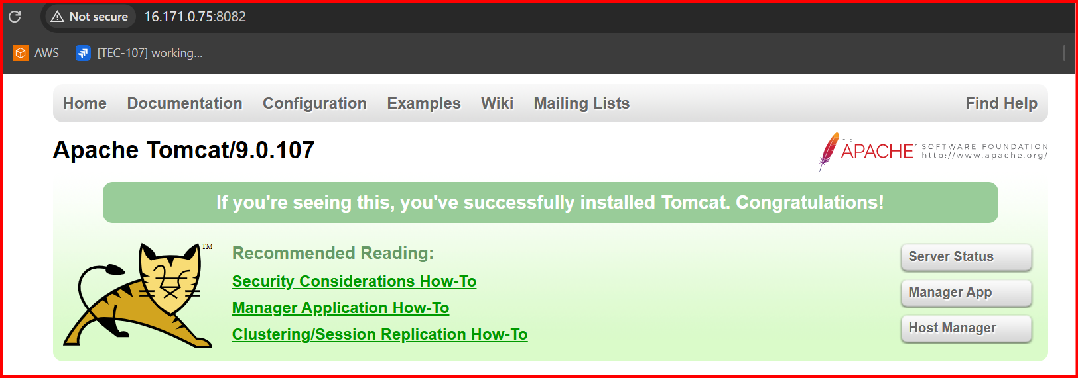

6. Deploy a sample app on webapps.

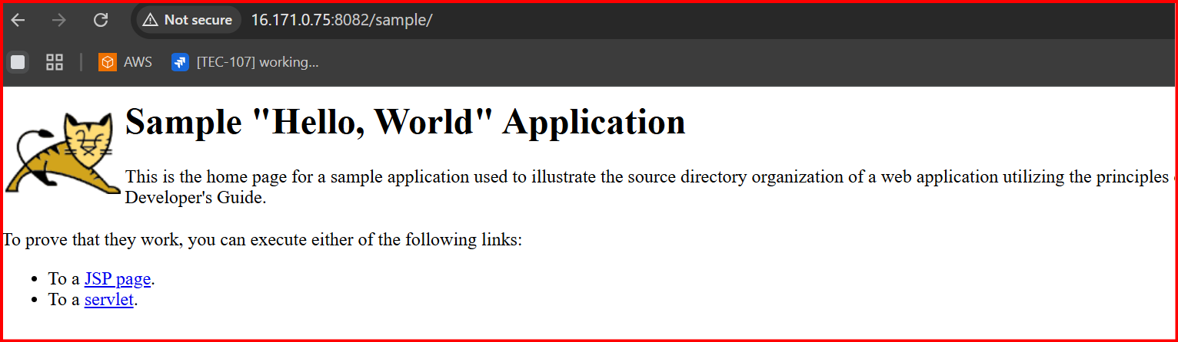

7. Create a tomcat.service file for tomcat.

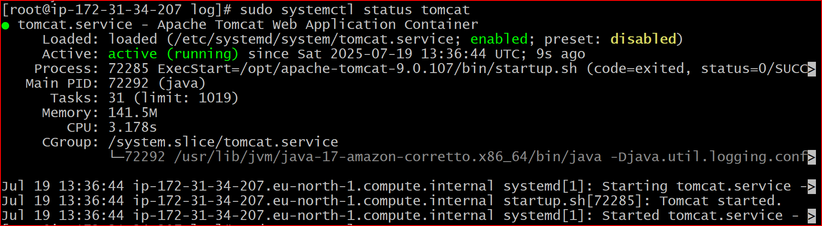

**8.Configure HA Proxy server.**

